Before the
Federal Communications Commission
Washington, D.C. 20554

In the matter of  Applications of DIRECTV Enterprises LLC:  Request for Special Temporary Authority to Conduct Telemetry, Tracking and Control During the Relocation of DIRECTV 1 to the 72.5º W.L. Orbital Location  Request for Modification of Blanket Authorization for 1,000,000 Receive-Only Earth Stations to Provide Direct Broadcast Satellite Service in the United States using the Canadian-Authorized DIRECTV 1 Satellite at the 72.5° W.L. Broadcast Satellite Service Location  Request for Modification of License to Relocate DIRECTV 1 to the 101º W.L. Orbital Location  Request for Special Temporary Authority to  Conduct Telemetry, Tracking and Control During the Relocation of DIRECTV 5 to the 109.8° W.L. Orbital Location | )  )  )  )  )  )  )  )  )  )  )  )  )  )  )  )  )  )  )  )  )  )  )  )  ) | File No. SAT-STA-20050427-00091  Call Sign S2627  File No. SES-MFS-20050427-00499  Call Sign E040024  File No. SAT-MOD-20030613-00120  File No. SAT-AMD-20041112-00208  Call Sign S2627  File No. SAT-STA-20050517-00104  Call Sign S2673

ORDER AND AUTHORIZATION

Adopted: July 14, 2005 Released: July 14, 2005

By the Deputy Chief, Satellite Division, International Bureau:

INTRODUCTION
- With this Order, we grant the request of DIRECTV Enterprises, LLC (DIRECTV) for special temporary authority, for a period not to exceed 180 days from the release of this Order, to relocate its DIRECTV 1 satellite from its current position at the 101.125º W.L. orbital location to the 72.5º W.L. orbital location, and to conduct Telemetry, Tracking and Control (TT&C) functions for the satellite until the time it reaches its new location, subject to certain conditions. With this Order, we also grant DIRECTV’s request for modification of its blanket authority to communicate with 1,000,000 receive-only earth stations, which DIRECTV uses to provide “local-into-local” signals to U.S. consumers, which will now communicate with the DIRECTV 1 satellite. The DIRECTV 1 satellite will operate at the 72.5º W.L. orbital location under a Canadian space station authorization issued to Telesat Canada (Telesat) by Industry Canada. Because the United States authorization for DIRECTV 1 will be terminated when it arrives at the 72.5º W.L. orbital location, we also dismiss, as moot, several pending applications relating to that space station. Customer traffic will be handed off from DIRECTV 5 to DIRECTV 1 while the satellites are briefly co-located at the 72.5º W.L. orbital location. Once the hand-off is completed, DIRECTV proposes to use the DIRECTV 5 satellite to replace a failing satellite at another orbital location. We grant DIRECTV’s request for special temporary authority to relocate the DIRECTV 5 satellite to the 109.8º W.L. orbital location of the failing satellite (nominally, the 110º W.L. orbital location) after the hand-off, and to conduct TT&C operations during that drift. Grant of these applications will permit DIRECTV to commence a series of satellite fleet moves needed to maintain continuity of service to DIRECTV customers at several locations, necessitated by the deteriorating condition of another satellite in the DIRECTV fleet.

BACKGROUND
- The DIRECTV 5 satellite currently operates at the 72.5º W.L. orbital location pursuant to an agreement between DIRECTV and Telesat, and under authorization issued by Industry Canada to Telesat. The proposed relocation of the DIRECTV 1 satellite to the 72.5º W.L. orbital location is based upon a revision to an agreement between DIRECTV and Telesat. The revised agreement will make the DIRECTV 5 satellite available for use at another, U.S.-licensed orbital location. DIRECTV has agreed to move the DIRECTV 1 satellite to the 72.5° W.L. orbital location, subject to necessary governmental approvals in the United States and in Canada. The agreement provides DIRECTV with an exclusive right to use all of the capacity on the DIRECTV 1 satellite at the 72.5° W.L. orbital location until at least September 30, 2008, unless DIRECTV launches two of three specific additional satellites before that date. Under the agreement, DIRECTV may, under certain circumstances, move the DIRECTV 1 satellite to one of its U.S.-licensed orbital locations, upon five days’ notice to Telesat, in the event that DIRECTV 1 is needed to replace some or all of the capacity of certain other DIRECTV satellites should any of those satellites fail in orbit.
- The agreement states that, once DIRECTV 1 is at the 72.5º W.L. orbital location, it will be operated under Telesat’s direction and control. DIRECTV will conduct TT&C for DIRECTV 1, on Telesat’s behalf, from a U.S.-licensed earth station, until Telesat has developed and installed the necessary facilities in Canada to perform such functions.
- On April 27, 2005, DIRECTV filed with the Commission a copy of its agreement with Telesat, and requested that the agreement be withheld from public inspection pursuant to Sections 0.457 and 0.459 of the Commission’s rules. On the same date, DIRECTV also filed a request for special temporary authority (STA) to relocate the DIRECTV 1 satellite, and a request for modification of its existing blanket earth station authorization. The Satellite Division of the International Bureau (Division) issued a Public Notice on April 29, 2005 accepting DIRECTV’s STA request for filing. The Division issued a public notice on May 25, 2005 accepting the DIRECTV blanket earth station request for filing. No comments were filed in response to either of these filings.
- On May 17, 2005, DIRECTV filed an application for an STA to relocate the DIRECTV 5 satellite, after its customer traffic at the 72.5º W.L. orbital location is transferred to the DIRECTV 1 satellite. On May 20, the Division issued a public notice accepting the STA request for filing. DIRECTV seeks authority to relocate the DIRECTV 5 satellite to the 109.8º W.L. orbital location, at which location it has applied to provide Direct Broadcast Service (DBS) on three licensed channels. No comments were filed in response to this request.

DISCUSSION

STA to Relocate DIRECTV 1
- The need to replace DIRECTV 5 with DIRECTV 1 results from the deteriorating condition of a third satellite, DIRECTV 6, at the 109.8º W.L. orbital location, which has experienced repeated solar array failures, as recently as March of this year. In order to ensure that the three DBS channels on that satellite remain fully operational, DIRECTV has turned off payload heaters on board the satellite. DIRECTV reports that the degradation of operations stemming from the solar array failures is expected to continue as more arrays fail. It is also likely that the solar array failures will be aggravated by the approaching annual solar eclipses occurring around the autumnal equinox.
- DIRECTV explains that the DIRECTV 5 and DIRECTV 6 satellites were designed with the same operational capabilities, including an antenna design optimized for service from the nominal 110º W.L. orbital location at which DIRECTV 6 is now providing service. Therefore, DIRECTV 5 is well-suited to replace DIRECTV 6 at the 110º W.L. orbital location, while the DIRECTV 1 satellite, which does not share that antenna design, is not as well-suited for service at that location. At the same time, DIRECTV 1 is capable of providing the local-into-local services currently provided by DIRECTV 5 at the 72.5º W.L. orbital location.
- Upon review, we find that DIRECTV has shown a grant of this request would serve the public interest. Specifically, this STA will enable DIRECTV to maintain continuity of DBS service from the 109.8º W.L. and 72.5º W.L. orbital locations, by authorizing the first in a series of satellite moves that will allow the replacement of a deteriorating DIRECTV 6 satellite.
- The DIRECTV 1 satellite will not be operating under a Commission authorization once the satellite arrives at the 72.5º W.L. orbital location. Accordingly, we are terminating the DIRECTV 1 license (Call Sign S2627) effective upon the arrival of the DIRECTV 1 satellite at the 72.5º W.L. orbital location. We also dismiss, as moot, all pending applications affecting the operations of DIRECTV 1 under Commission authority.
- We have exchanged letters with Industry Canada in order to ensure that there is a mutual understanding regarding the operation of the DIRECTV 1 and DIRECTV 5 satellites. The understandings, and the factual background for these understandings, are provided as Annex A and are material considerations for the authorization contained in this Order. In general, the exchange of letters indicates that space station operations of DIRECTV 1 and DIRECTV 5 at the 72.5° W.L. orbital location will be pursuant to authorization of Telesat by Industry Canada. The two satellites will both operate for a brief period at the 72.5° W.L. orbital location, to accommodate testing and the transfer of customer traffic.
- Finally, we address potential concerns about the life of the DIRECTV 1 satellite because it is a model HS601 satellite. Other satellites of this design have experienced satellite control processor failures. More particularly, the HS601 satellites are susceptible to a type of satellite control processor failure called a “tin whisker” failure, referring to the growth of a pure tin crystal, resembling a whisker, on the input power relay unit. One of the satellite control processors on DIRECTV 1 failed on July 5, 1998. Since that time, the DIRECTV 1 satellite has continued to operate using its backup satellite control processor.
- We have previously discussed information regarding the tin whisker failure phenomenon in an application for the DIRECTV 3 satellite, also an HS601 model. One of the two satellite control processors on the DIRECTV 3 satellite failed on May 4, 2002. In the DIRECTV 3 proceeding, the Satellite Division requested additional information on the statistical failure rate of satellite control processors caused by tin whisker short circuits. In response, DIRECTV relied on a statistical analysis submitted by PanAmSat after it suffered a similar processor failure. The analysis concluded that time in orbit was the best predictor of future probability for processor failure caused by tin whiskers. DIRECTV relied upon that analysis to conclude that its DIRECTV 3 satellite had exceeded the time in orbit of all failed HS601 satellite control processors.
- On or about May 31, 2005, the Commission became aware of another HS601 satellite control processor failure in a satellite that had spent more time in orbit than any prior failure. Since this fact could call into question the conclusion of the statistical analysis previously relied upon by DIRECTV, the Satellite Division requested additional information from DIRECTV. In a letter filed June 13, 2005, DIRECTV provided additional information on tin whisker failures and the potential impact should such a failure occur with DIRECTV 1. DIRECTV concluded that the May 2005 failure was an extreme event, but nevertheless still within the current model of probability. Assuming the continued validity of the failure probability model, DIRECTV 1 is well past the time in orbit where another satellite control processor failure should be expected. Based on the information provided by and relied upon by DIRECTV, we have no basis for requiring it to place DIRECTV 1 in a storage orbit.

Blanket Authorization for Earth Stations to Communicate with DIRECTV 1
- The Commission's DISCO II Order adopted the framework under which the Commission considers requests for non-U.S. licensed satellite systems to serve the United States. To implement this framework, the Commission established a procedure by which a service provider in the United States could request immediate access to an in-orbit, foreign satellite that would serve the U.S. market. This procedure requires the service provider to apply for an earth station license that lists the foreign satellite as an authorized point of communication.
- In the DIRECTV 5 Order, we followed the precedent established in the DBAC Order, examining DIRECTV’s application for blanket earth station authorization at the 72.5º W.L. orbital location. We examined in particular whether there were de jure or de facto barriers to entry for the provision of analogous service by U.S. operators in Canada, and whether any such barrier would cause competitive distortions in the United States. We considered those factors together with other public interest considerations to determine whether grant of the request would serve the public interest. We found that grant of DIRECTV’s application was in the public interest because, among other things, the application proposed to provide local-into-local services in 24 markets not yet served by DIRECTV, thereby improving the quality of service to U.S. customers. In this case, we find no material difference in the competitive and public interest considerations for service to U.S. earth stations from the Canadian-licensed 72.5º W.L. orbital location, whether they communicate with the DIRECTV 5 satellite or the DIRECTV 1 satellite. Consequently, the conclusions we reached in the DIRECTV 5 Order remain valid for the instant modification application, which requests communication with the DIRECTV 1 satellite.
- In connection with its application for reception of signals from DIRECTV 5 at the 72.5º W.L. orbital location, DIRECTV indicated that DIRECTV 5 could operate within the envelope created by the 1996 Canadian filing, designated CAN-BSS3. DIRECTV also indicated that “unless a BSS system that is entitled to protection comes into operation, DIRECTV plans to operate at levels that exceed those notified in the CAN-BSS3 filing on a non-harmful interference basis pursuant to Article 4.4 of the ITU Radio Regulations.” DIRECTV also asserted that these higher levels will be “fully enveloped” by Canada’s 2003 filing, designated CAN-BSS6, and that “if necessary DIRECTV will be able to switch to the lower-power operations while maintaining the 24 additional markets without any service interruption to consumers.” We conditioned DIRECTV’s prior blanket earth station authorization for service from the 72.5° W.L. orbital location consistent with these representations. We retain that condition, unchanged, in this authorization.
- In its application to modify its blanket authorization for one million receive-only earth stations, DIRECTV seeks authority to replace DIRECTV 5 with DIRECTV 1 as the space station point of communication at the 72.5° W.L. orbital location. On review of the pending application, as well as the prior application for service from DIRECTV 5 at that location, we find no material difference in the coverage contour of the two satellites from the 72.5° W.L. orbital location. We also note that the DIRECTV 1 satellite operates at a power level that is 1 dBW less than is emitted from DIRECTV 5. Consequently, we find that the substitution of DIRECTV 1 as the point of communication will not result in additional interference to adjacent operations. We therefore grant DIRECTV’s application to modify its blanket earth station authorization, substituting DIRECTV 1 as the space station point of communication for the authorized earth stations.

STA to Relocate DIRECTV 5
- Upon relocation of DIRECTV 1 to the 72.5° W.L. orbital location, DIRECTV will transfer customer traffic from DIRECTV 5 to DIRECTV 1. DIRECTV 5 will no longer provide service at that location. DIRECTV has applied for special temporary authority to conduct TT&C during the relocation of the DIRECTV 5 space station from the 72.5° W.L. orbital location to the 109.8° W.L. orbital location, where it will replace DIRECTV 6, a satellite with failing solar panels. The period for public comment on this STA request has passed. No comments were filed. Thus, we grant DIRECTV authority to conduct TT&C during the relocation of the DIRECTV 5 from the 72.5° W.L. orbital location to the 109.8° W.L. orbital location. This STA will enable DIRECTV to maintain continuity of DBS service to its customers from the 109.8º W.L. orbital location.

ORDERING CLAUSES
- Accordingly, IT IS ORDERED that, pursuant to Section 25.120 of the Commission’s rules, 47 C.F.R. § 25.120, the request of DIRECTV Enterprises, LLC to relocate the DIRECTV 1 satellite from the 101.125º W.L. orbital location to the 72.5º W.L. orbital location and to conduct Telemetry, Tracking and Control functions during the drift and until January 10, 2006, File No. SAT-STA-20050427-00091, is GRANTED, subject to the following conditions:
i.) During the drift to the 72.5º W.L. orbital location, DIRECTV Enterprises, LLC shall not operate the main communications payload on DIRECTV 1.
ii.) DIRECTV Enterprises, LLC shall coordinate all drift orbit Telemetry, Tracking, and Control operations with other potentially affected in-orbit operators.
iii.) During relocation of the DIRECTV 1 satellite, operations shall be on a non-harmful interference basis, meaning that DIRECTV Enterprises, LLC shall not cause interference to, and shall not claim protection from interference caused to it by, any other lawfully operating satellites.
iv.) In the event that any harmful interference is caused as a result of operations during the relocation of the DIRECTV 1 satellite, DIRECTV Enterprises, LLC, shall cease operations immediately upon notification of such interference and shall inform the Commission immediately, in writing, of such an event.
v.) DIRECTV Enterprises, LLC shall provide the Chief, Satellite Division, International Bureau, with 30 days notice (confirmed email considered sufficient) prior to commencement of use of Telesat Canada’s earth stations to provide the earth station segment of Telemetry, Tracking, and Control communications.
- IT IS FURTHER ORDERED that, effective upon the date when the DIRECTV 1 satellite reaches the 72.5° W.L. orbital location, the license for that satellite (Call Sign S2627) IS TERMINATED. IT IS FURTHER ORDERED that DIRECTV Enterprises, LLC, shall inform the Commission, through a letter to the Chief, Satellite Division, Federal Communications Commission, within five business days following the date on which the DIRECTV 1 satellite reaches the 72.5° W.L. orbital location.
- IT IS FURTHER ORDERED that pending applications affecting the DIRECTV 1 satellite, File No. SAT-MOD-20030613-00120, File No. SAT-AMD-20041112-00208, are DISMISSED.
- IT IS FURTHER ORDERED that, pursuant to Section 25.137(d) of the Commission’s rules, 47 C.F.R. § 25.137(d), the application of DIRECTV Enterprises, LLC, File No. SES-MFS-20050427-00499, IS GRANTED, and the authorization of DIRECTV Enterprises, LLC to use 1,000,000 receive-only Earth stations to receive transmissions in the 12.2-12.7 GHz frequency band from the 72.5° W.L. orbital location, Call Sign E040024, IS MODIFIED to specify DIRECTV 1 as the space station point of communication, until September 30, 2008, consistent with the technical parameters specified in its application, and subject to the following condition:
Operations shall be consistent with applicable coordination agreements; to the extent such agreements have not been reached, operations shall be on a non-harmful interference basis, i.e., operations of the DIRECTV 1 satellite shall not cause interference to, and shall not claim protection from, interference caused to it by any other lawfully operating satellites.
- IT IS FURTHER ORDERED that, pursuant to Section 25.120 of the Commission’s rules, 47 C.F.R. § 25.120, the request of DIRECTV Enterprises, LLC to relocate the DIRECTV 5 satellite from the 72.5º W.L. orbital location to the 109.8º W.L. orbital location, and to conduct Telemetry, Tracking and Control functions during the drift, File No. SAT-STA-20050517-00104 is GRANTED, effective upon successful transfer of customer traffic from the DIRECTV 5 satellite to the DIRECTV 1 satellite at the 72.5º W.L. orbital location, and for a period of 30 days thereafter, subject to the following conditions:
i.) During the drift and upon arrival at the 109.8º W.L. orbital location, DIRECTV Enterprises, LLC shall not operate the main communications payload on DIRECTV 5.
ii.) DIRECTV Enterprises, LLC shall coordinate all drift orbit Telemetry, Tracking, and Control operations with other potentially affected in-orbit operators.
iii.) During relocation of the DIRECTV 5 satellite, DIRECTV Enterprises, LLC’s operations shall be on a non-harmful interference basis, meaning that DIRECTV Enterprises, LLC shall not cause interference to, and shall not claim protection from interference caused to it by, any other lawfully operating satellites.
iv.) In the event that any harmful interference is caused as a result of DIRECTV Enterprises, LLC’s operations during the relocation of the DIRECTV 5 satellite, DIRECTV Enterprises, LLC, shall cease operations immediately upon notification of such interference and shall inform the FCC in writing immediately of such an event.
- IT IS FURTHER ORDERED that DIRECTV Enterprises, LLC, shall inform the Commission, through a letter to the Chief, Satellite Division, FCC, within five business days following the date on which the DIRECTV 5 satellite departs the 72.5° W.L. orbital location.
- DIRECTV Enterprises, LLC is afforded thirty days to decline these authorizations as conditioned. Failure to respond within this period will constitute formal acceptance of the authorizations as conditioned.
- This Order is issued pursuant to authority delegated in Section 0.261 of the Commission’s rules, 47 C.F.R. § 0.261, and is effective upon release.
FEDERAL COMMUNICATIONS COMMISSION

Cassandra C. Thomas
Deputy Chief
Satellite Division
International Bureau
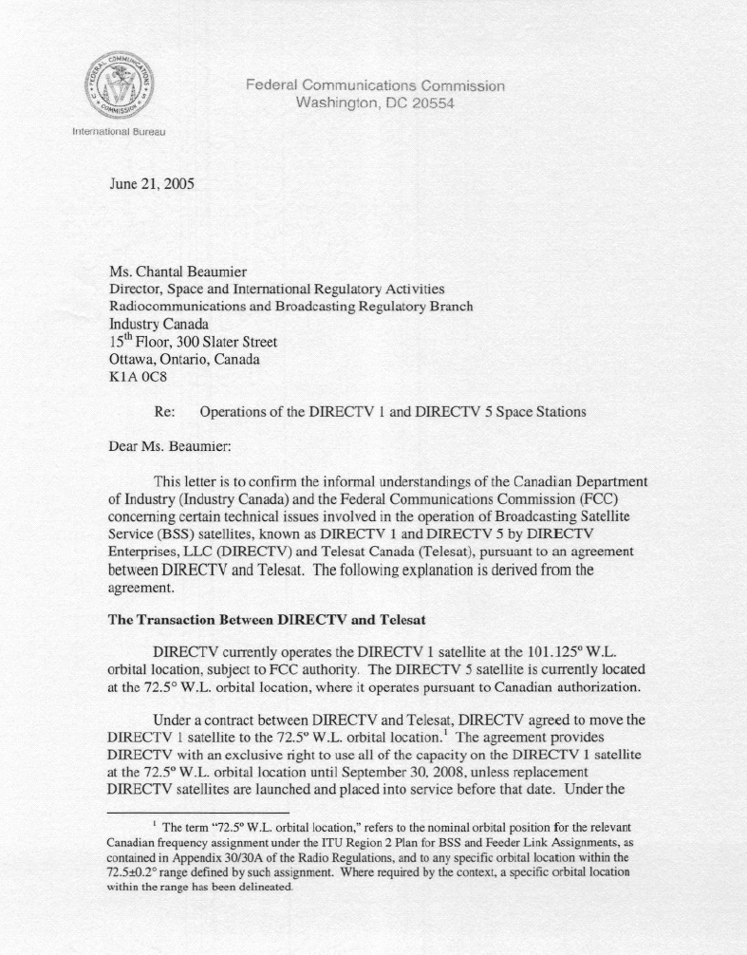
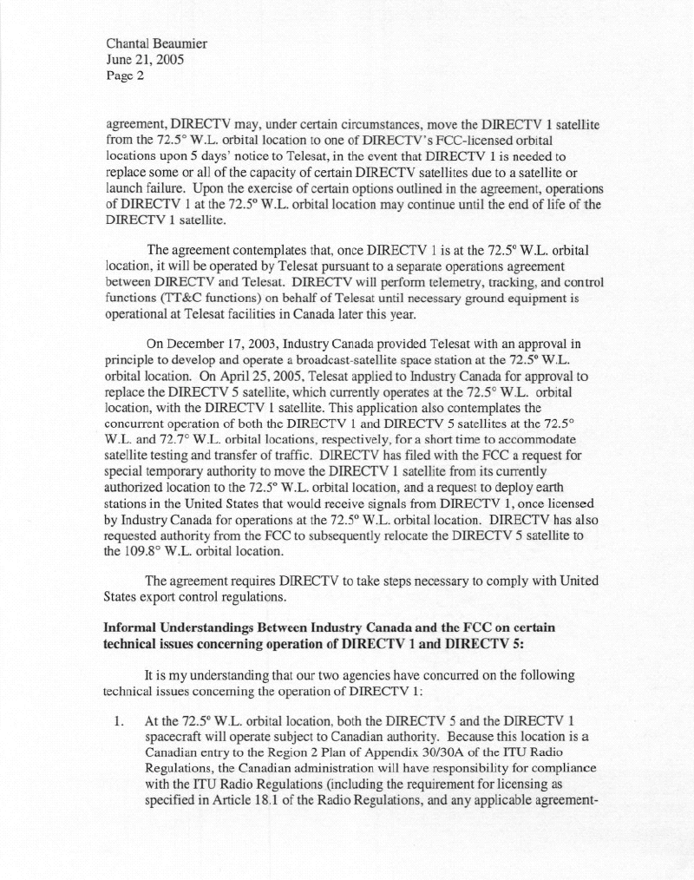
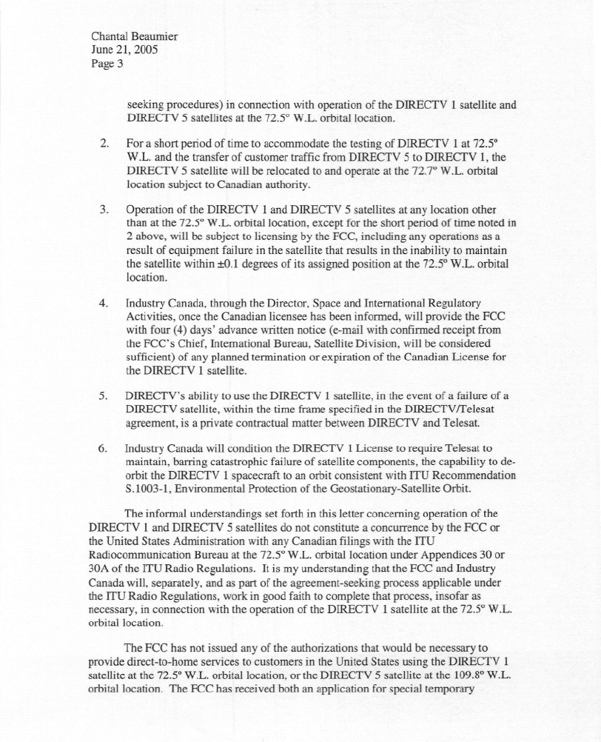
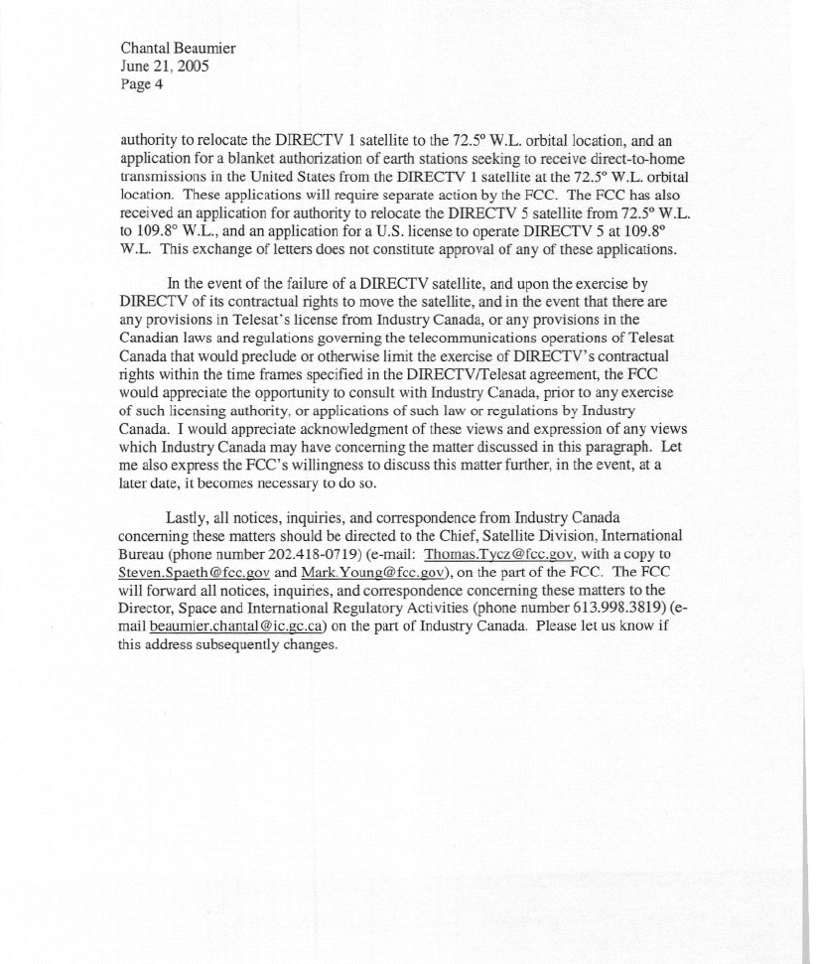
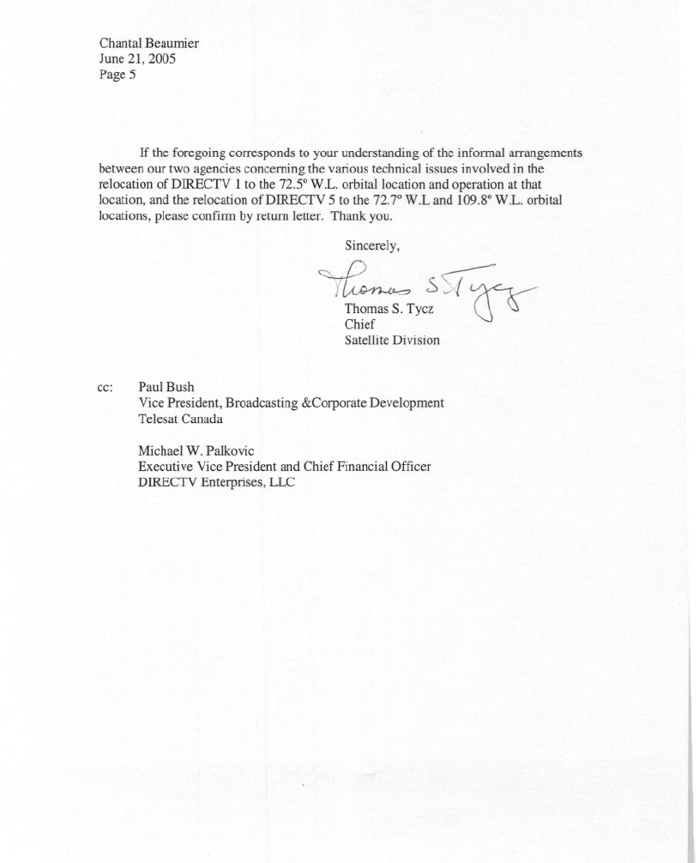
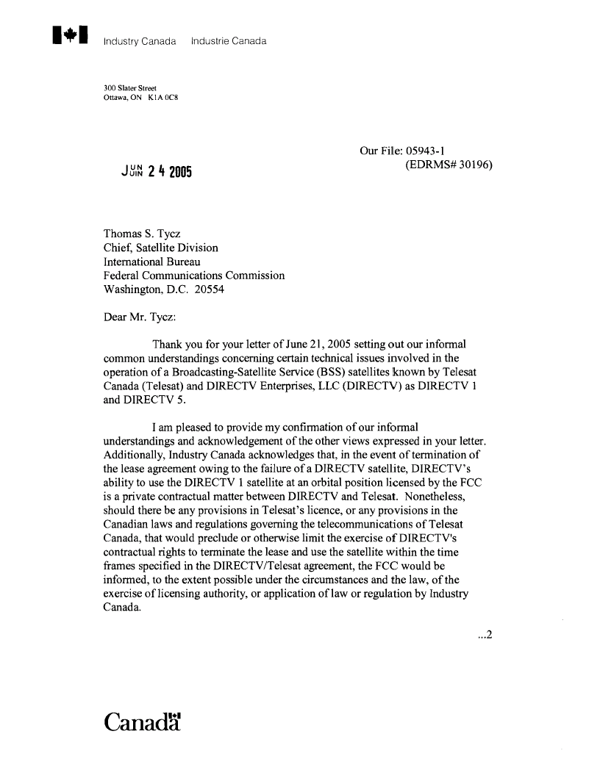
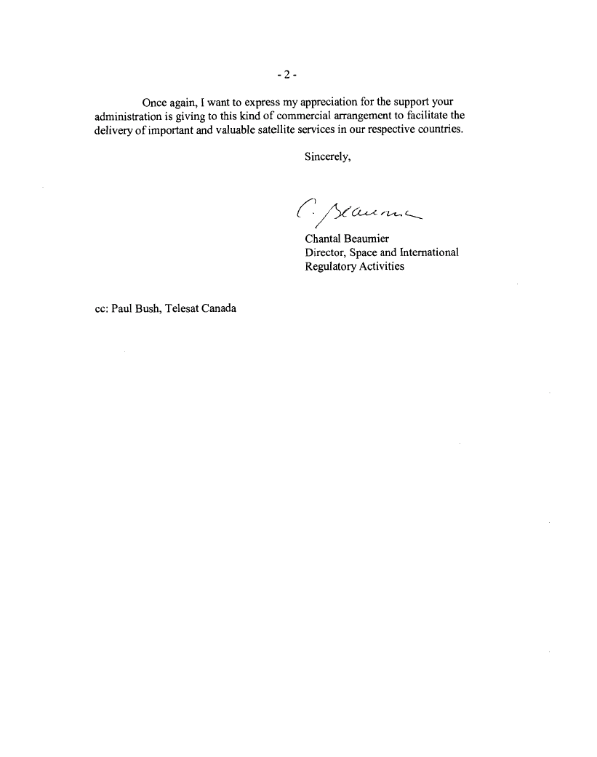

The term “72.5° W.L. orbital location,” as used in this Order, refers to the nominal orbital position for the relevant Canadian frequency assignment under the International Telecommunication Union (ITU) Region 2 Plan for BSS and Feeder Link Assignments, as contained in Appendix 30A of the Radio Regulations, and to any specific orbital location within the 72.5±0.2° range defined by such assignment.
The term “local-into-local,” as used in this Order, refers to provision via satellite retransmission of local broadcast channels to subscribers who reside in the local TV station’s market, which is defined as a Designated Market Area, or “DMA.” See 17 U.S.C. § 122(j)(2)(A). This action is taken pursuant to Section 25.131 of the Commission’s Rules. See 47 C.F.R. § 25.131(j) (requiring most receive-only Earth stations that would operate with non-U.S. licensed space stations to be licensed).
Application of DIRECTV Enterprises, LLC Request for Special Temporary Authority for the DIRECTV 5 Satellite, Application of DIRECTV Enterprises, LLC Request for Blanket Authorization for 1,000,000 Receive Only Earth Stations to Provide Direct Broadcast Satellite Service in the United States using the Canadian Authorized DIRECTV 5 Satellite at the 72.5º W.L. Broadcast Satellite Service Location, Order and Authorization, 19 FCC Rcd 15529 (Int’l Bur., Sat. Div. 2004) (DIRECTV 5 Order).
DIRECTV holds licenses to operate satellites pursuant to the U.S. assignments for the 101º, 110º and 119º W.L. orbital locations under the ITU Region 2 Plan for BSS and Feeder Link Assignments.
47 C.F.R. §§ 0.457, 0.459. See DIRECTV Enterprises, LLC, Request for Confidential Treatment (filed April 27, 2005).
File No. SAT-STA-20050427-00091; File No. SES-MFS-20050427-00499.
Policy Branch Information, Satellite Space Applications Accepted for Filing, Report No. SAT-00288 (released April 29, 2005).
Satellite Communications Services re: Satellite Radio Applications Accepted for Filing, Report No. SES-007115 (released May 25, 2005).
File No. SAT-STA 20050517-00104.
Policy Branch Information, Satellite Space Applications Accepted for Filing, Report No. SAT-00292.
See Application of DIRECTV Enterprises, LLC for Authorization to Operate DIRECTV 5, a Direct Broadcast Satellite, at 109.8º W.L., File No. SAT-OA-20050504-00093 (filed May 4, 2005). See also Policy Branch Information, Satellite Space Applications Accepted for Filing, Report No. SAT-00303 (released July 1, 2005).
DIRECTV Enterprises, LLC, Request for Special Temporary Authority to Relocate DIRECTV 1 to 72.5° W.L. and to Conduct Telemetry, Tracking and Control Operations for an Interim Period, File No. SAT-STA-20050427-00091 (DIRECTV 1 STA Application), at 3.
DIRECTV 1 STA Application at 3.
See DIRECTV 5 Order, 19 FCC Rcd. 15529.
File No. SAT-MOD-20030613-00120; File No. SAT-AMD-20041112-00208.
See Letter from James Butterworth, Senior Vice President, DIRECTV Enterprises, LLC, to Marlene H. Dortch, Secretary, Federal Communications Commission (dated June 13, 2005) (DIRECTV Tin Whisker Letter).
Id. at 2.
DIRECTV, Inc. Request for Special Temporary Authority for the DIRECTV 3 Satellite, Order, 19 FCC Rcd 11044 (Sat. Div., Int’l Bur. 2004).
DIRECTV Tin Whisker Letter at 1.
See PanAmSat Licensee Corp., Further Supplement to STA, File No. SAT-STA-20030324-00039 (filed April 24, 2003).
DIRECTV Tin Whisker Letter.
Id. at 3.
See Amendment of the Commission's Regulatory Policies to Allow Non-U.S. Licensed Satellites Providing Domestic and International Service in the United States, Report and Order, IB Docket No. 96-111, 12 FCC Rcd 24094 (1997) (DISCO II or DISCO II Order).
See DISCO II, 12 FCC Rcd at 24174, ¶ 186. For a more detailed summary of the DISCO II framework, see Amendment of the Commission's Regulatory Policies to Allow Non-U.S.-Licensed Space Stations to Provide Domestic and International Satellite Service in the United States, First Order on Reconsideration, 15 FCC Rcd 7207, 7209-10, ¶ 4-5 (1999) further recon. denied 16 FCC Rcd 19794 (2001) (DISCO II First Reconsideration Order).
DIRECTV 5 Order, 19 FCC Rcd at 15532-5, citing Digital Broadcasting Application Corp., Order, 18 FCC Rcd 9455 (Int’l Bur. 2003) (DBAC Order).
Id. at 15532.
Id.
DIRECTV 5 Order, 19 FCC Rcd at 15536 ¶ 18, 15538 ¶ 25 (citing Letter from William M. Wiltshire, Counsel for DIRECTV Enterprises, LLC, to Thomas Tycz, Chief, Satellite Division, dated May 24, 2004, at 2).
Id.
Id.
Operating authority for DIRECTV 5 at the 109.8° W.L. orbital location will be addressed separately. DIRECTV has filed an application seeking authority for DIRECTV 5 to replace DIRECTV 6 in providing DBS service at the 109.8° W.L. orbital location. See SAT-A/O-20050504-00093; Policy Branch Information, Satellite Space Applications Accepted for Filing, Report No. SAT-00303 (released July 1, 2005). See also, SAT-STA-20050518-00105 (seeking special temporary authority for up to 180 days, to relocate the DIRECTV 6 satellite from the 109.8° W.L. orbital location to the 109.7° W.L. orbital location for up to one week to accomplish a customer traffic hand-off, and thereafter to the 109.5° W.L. orbital location for the remainder of the special temporary authority).

